Why It Feels Good
to be Our Friend

FRIENDS help donated books find news homes, while helping the library in the process.

FRIENDS enjoy working with talented and creative folks who share a passion for lifelong learning.

FRIENDS make a difference by creating greater awareness and support for Library programs and services.

FRIENDS enjoy the sincere appreciation of the Library’s staff and patrons, who value their service, time, and talents.

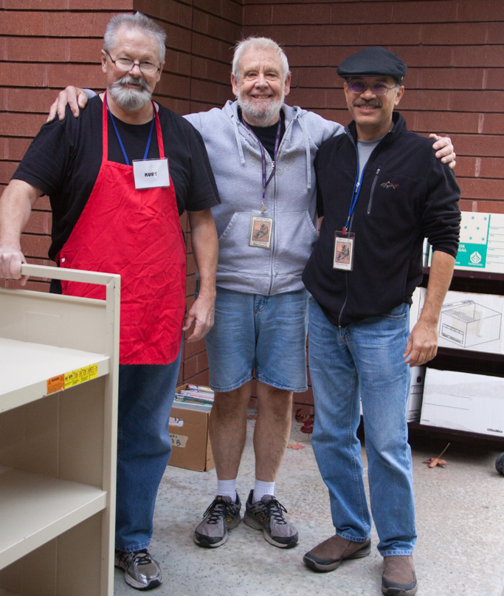
FRIENDS help to make the Sunnyvale Public Library the informational and cultural hub of our community.
Get Involved . . .
And let us put your talents to work!

Volunteers enrich our community and their own lives by sharing their time, skills, and talents. Whether you have plenty of time or just a few hours, you can make a difference.

Volunteers are needed to help with the following:

⃞ Book sales
⃞ Sorting book donations
⃞ Online book sales
⃞ Library lobby area book pricing and sales
⃞ Membership recruitment and recognition
⃞ Publicity / Social media
⃞ Website
⃞ Antique and/or collectible books
⃞ Special event planning
⃞ Other: ________________________________

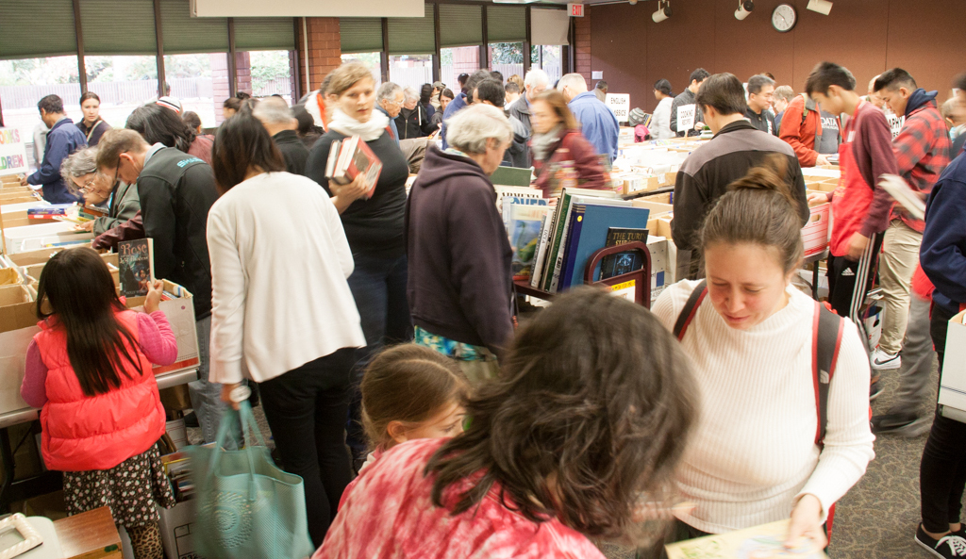
Friends of the Sunnyvale  Public Library  P. O. Box 3714  Sunnyvale, CA 94088  FOTSVL.ORG  email: info@fotsvl.org | Sunnyvale Public Library  665 West Olive Avenue  Sunnyvale, CA 94086  (408) 730-7300  sunnyvalelibrary.org

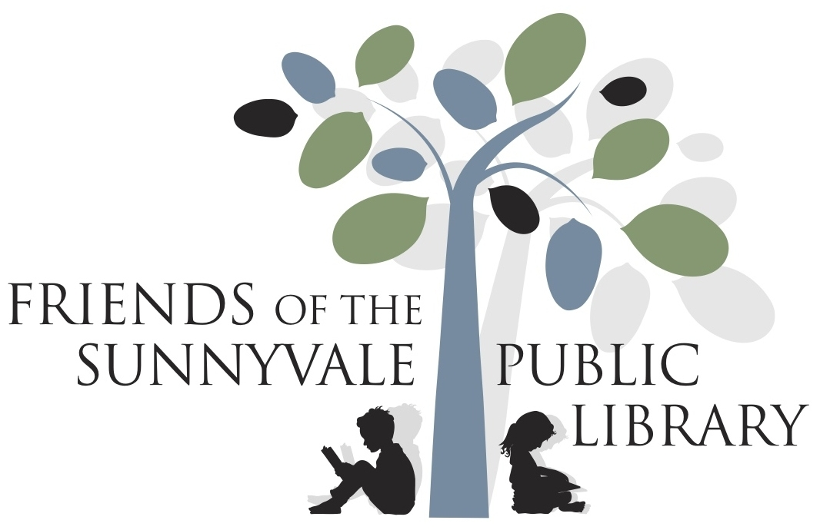

Love Your Library?
Become a Friend!
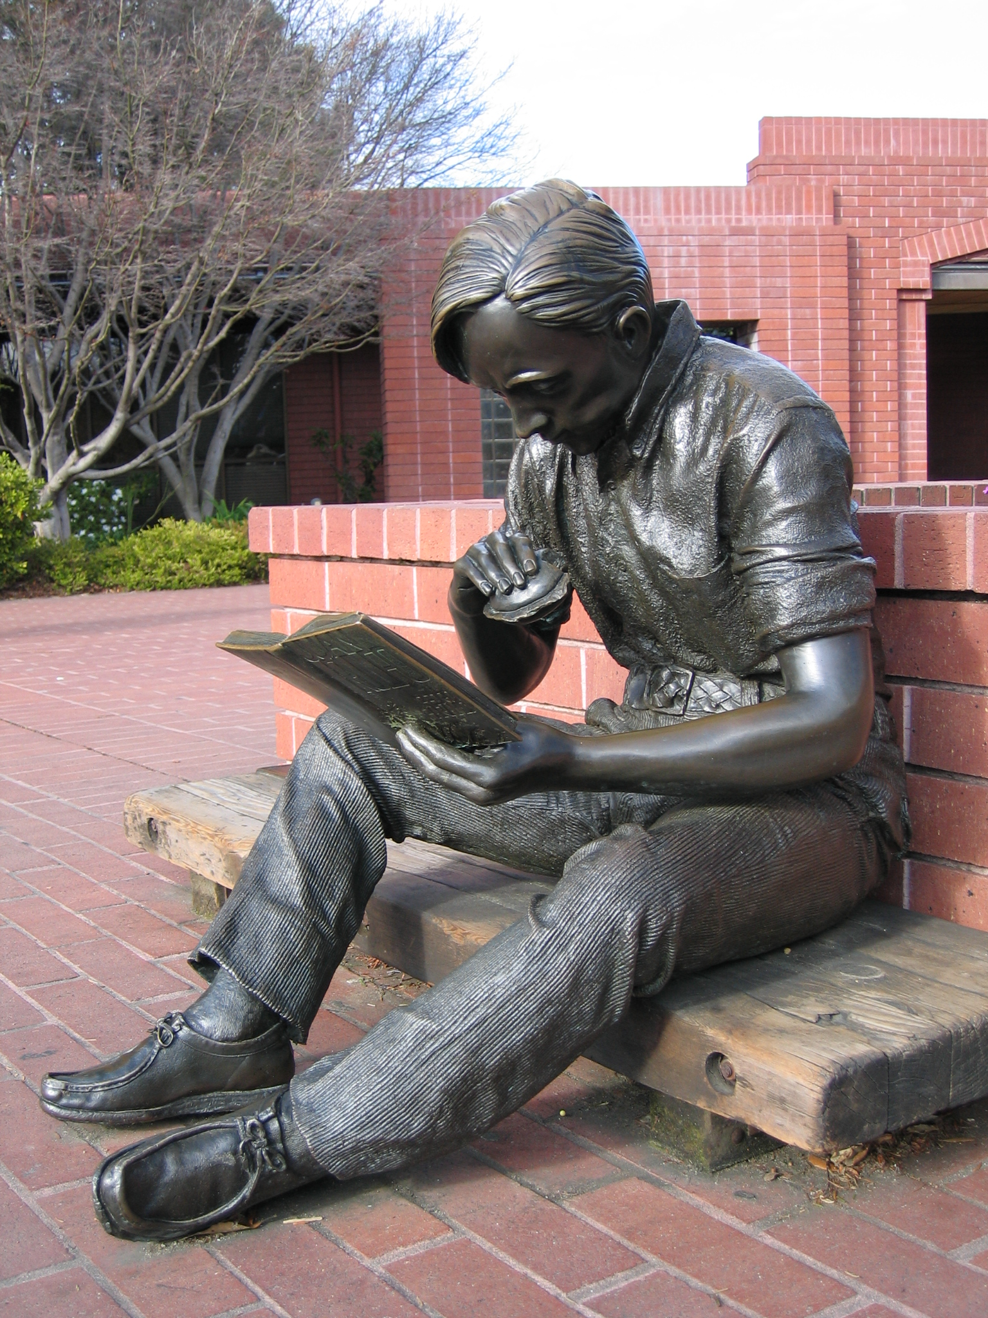

Who are the Friends of the
Sunnyvale Public Library?

The Friends of the Sunnyvale Public Library is a group of volunteers dedicated to supporting the Sunnyvale Public Library.

Through large bi-monthly book sales, sales from an ongoing lobby store, on-line sales, and donations, we raise funds to help the library to purchase materials, equipment, and furnishings, and to provide entertaining programs and educational opportunities.

When You Join Us, You Will . . .
⃘ Raise funds to support lively cultural events that celebrate the diversity of our community and help attract new visitors.
⃘ Champion investments in technology, capital improvements, and e-resources to ensure access for all our Library users.
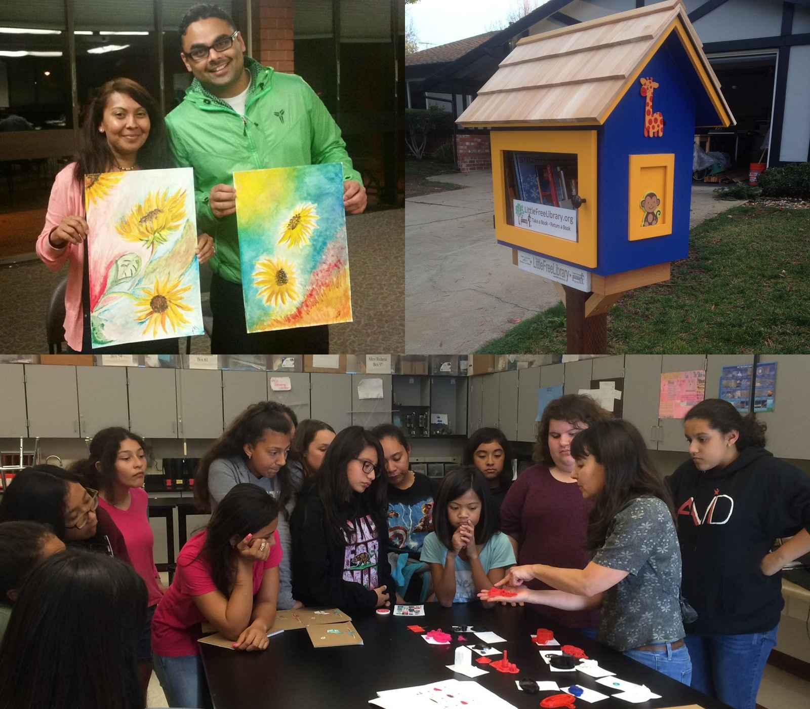
⃘ Sponsor hands-on learning and educational programs.

How does my gift to the Friends
make a difference?

Your support of the Friends of the Sunnyvale Public Library makes it possible to offer a wide variety of cultural experiences and innovative programs that support lifelong learning for people of all ages.
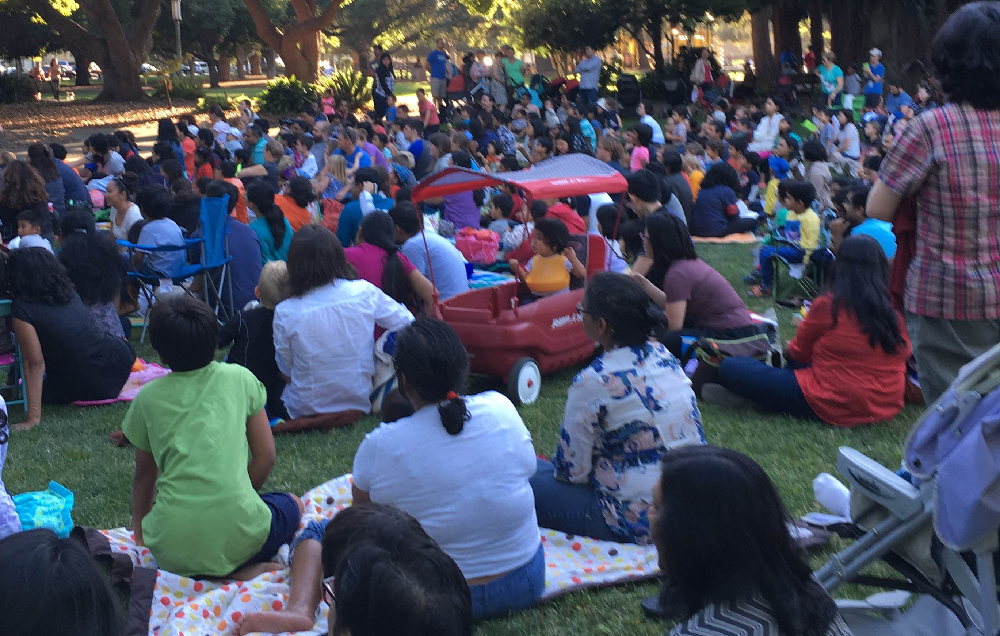
Whether it is Opera in the Library, Puppet Shows at Washington Park, MakeHer classes, the Summer Reading program, or Pop-up Libraries at the Sunnyvale Farmers Market, the support of the Friends strengthens our community by bringing residents together to learn, discover, and grow.

Your support will make a difference!

A great Library provides inspiration and resources for community members to expand their knowledge and to use what they learn to improve their lives and their community.

Be a Friend
and
Help Make the Library Great!

Yes!
I Want to be a Friend!

⃞ Regular Member – Priority access to all bi-monthly book sales for a year. ($10)
⃞ Life Membership – Priority access to all bi-monthly book sales for life. ($200)
⃞ Community Builder – All benefits of life membership plus special recognition by the library. ($500)
⃞ Superhero – All Community Builder benefits, plus more recognition. ($1000)
⃞ In addition to my membership, I would like to donate $___________ to the Friends.
⃞ My contribution will be matched by my employer,

All donations are tax-deductible.

Name:
Email:

(Please print clearly!)

Please make your check payable to Friends of the Sunnyvale Public Library, PO Box 3714, Sunnyvale, CA, 94088-3714

Or pay at a book sale.

